Name: Sadaf Najeem Mulla

PRN No: 2019BTECS00038

Batch: B2

**High Performance Computing Lab**

**Practical No. 8**

**Problem Statement 1:** Study and implement 2D Convolution using MPI. Use a different number of processes and analyze the performance.

**Problem Statement 2:** Implement dot product using MPI. Use a different number of processes and analyze the performance.

|  |  |
| --- | --- |
| **Number Of Processes** | **Time** |
| **2** | **0.000780** |
| **4** | **0.002225** |
| **6** | **0.001078** |
| **8** | **0.001009** |
| **10** | **0.001460** |
| **12** | **0.002167** |
| **14** | **0.002638** |
| **16** | **0.003239** |

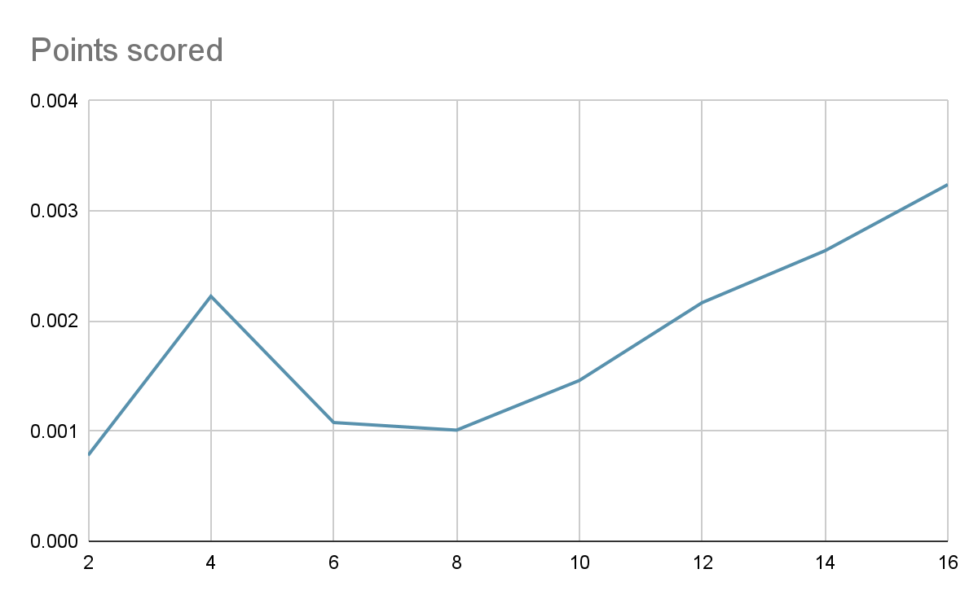

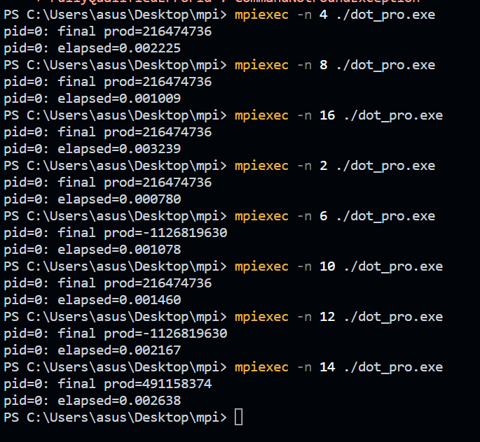

**Problem Statement 3:** Implement Prefix sum using MPI. Use a different number of processes and analyze the performance.

|  |  |
| --- | --- |
| **No. Of Processes** | **Time** |
| **2** | **0.000856** |
| **4** | **0.002758** |
| **6** | **0.001610** |
| **8** | **0.002306** |
| **10** | **0.002557** |
| **12** | **0.002998** |
| **14** | **0.003693** |
| **16** | **0.004219** |

